Artifact Three Narrative

The third artifact I selected is from my CS 360: Data Structures and Algorithms - Analysis and Design course which I took during the Fall of 2023. The goal of this project was to create a mobile app inventory system that gives the user the ability to add, modify, and delete items from an attached database. Its purpose was to demonstrate CRUD operations within a system and is designed to model an inventory system for an IT department. Upon starting the app, the user will open the login page, which is currently not configured to authenticate user accounts. The user can advance into the app by clicking “Login” which will take them to the app home page. From here, the database is empty so the user will need to populate it. By clicking the plus button in the top right corner, the user will be navigated to the Add Item page which they can use to add items to the database. After adding all the desired items, back on the home page, the user can click on the listed categories to display all the items in order based on that category. To modify or delete items, the user can click on the hamburger button and select “Update Item”, Which will navigate to the Update/Delete page where they can make any necessary changes. I chose this artifact as I felt it would be a great example to not only showcase an understanding of how to integrate database systems with a computer program, but also an ability to develop mobile apps as most software products have matching apps.

For my planned enhancements, I wanted to develop a RestAPI to allow user authentication into the app, redesign the hamburger menu, and add a sign out menu option which will display a dialog box. The original version of the app properly demonstrates CRUD operations by managing the items added to the database. Before my final submission of the app in my CS 360 course, I attempted to add a RestAPI feature as practice to help further my skills in Android development but was unsuccessful. I would like to revisit this feature and finish developing to build a more complete app. To start, I would need to create another database table to store the user accounts. This table will be used to authenticate users account for app access I will also need to create another app page that will allow for new accounts to be created as well. Once new accounts are created, users will be able to login with their email address and password. I also plan on updating the hamburger menu to list the options for add, update/delete, and sign out, while also adding a sign out feature which will include an alert box to confirm user sign out.

For submission, I submitted a version of the original code, and the new refactored code which will adhere to course by demonstrating my ability to “design, develop, and deliver professional-quality applications as well as develop a secure architecture to prevents vulnerabilities, bugs, and design flaws”, and “develop a security mindset that anticipates adversarial exploits in software architecture and designs to expose potential vulnerabilities, mitigate design flaws, and ensure privacy and enhanced security of data and resources.” By undertaking this planned enhancement, I was able to increase my understanding and ability with Android development. During the enhancement, I ran into an issue with reading the database to confirm user access. It was an issue that took me a few days to troubleshoot. While troubleshooting, I learned of and utilized a few development tools in Android Studio. The first was App Inspection, which allows for live updates of any attached database or network components. With App Inspection, I was able to, in real time, verify if my app could add new users and run queries to test reading data. The second was Logcat, which is an error log of the running app. With this tool, I was able to isolate the reason why my app was crashing and begin troubleshooting from that point.

**

**App Screenshots**

Add User

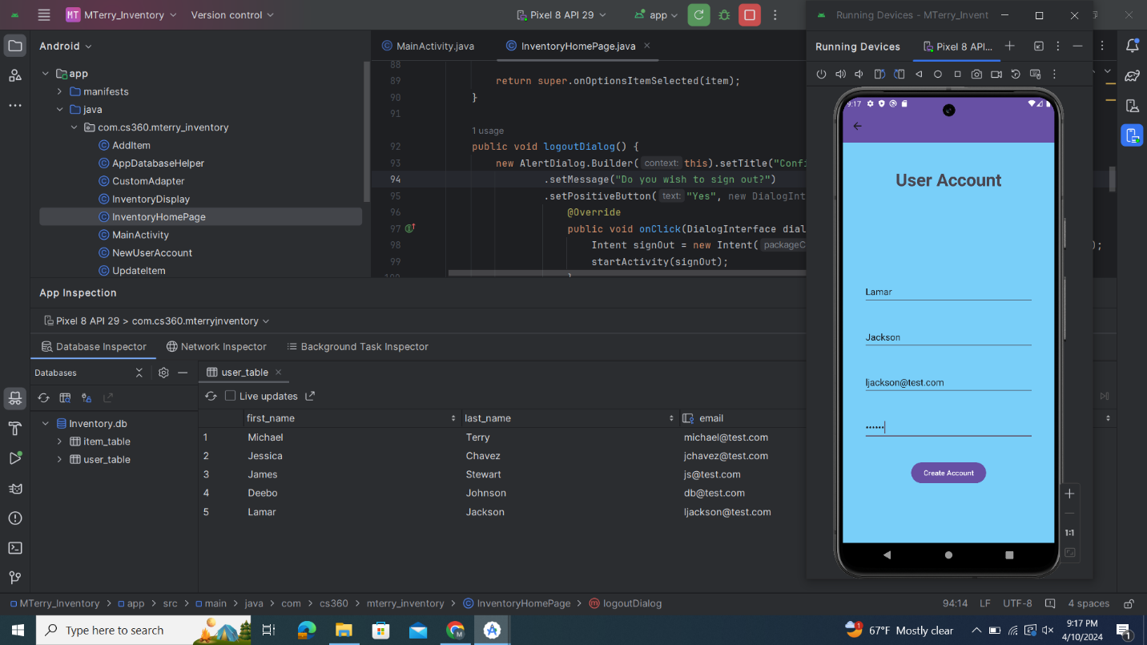

Login

Menu Items

Sign Out

